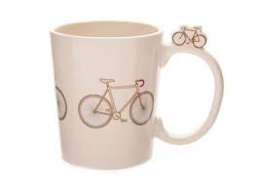

The cycle mug is for exercise loving people so they can start their day with full of refreshness!

Product: Cycle Mug

Price:630 PKR

CONTACT US: Address: Aptech Metro StarGate Karachi

Email: feedback@aptech-education.com.pk